A Project Report On

**Health Information System Using Blockchain Technology**

**S**ubmitted in partial fulfilment of the requirements

In

**Computer Engineering**

By

**Yash Chavan (17102024)**

**Amey Balekundri (17102015)**

**Hemanshu Bafna (17102032)**

**Hiten Bhatia (15102044)**

Under the guidance of

**Prof. P. P. Adivarekar**



**Department of Computer Engineering**

A.P. Shah Institute of Technology G. B. Road, Kasarvadavli , Thane(W), Mumbai-400615

UNIVERSITY OF MUMBAI

**Academic Year 2020-2021**

**Approval Sheet**

This Project Report entitled ***“Health Information System Using Blockchain Technology”*** Submitted by ***“Yash Chavan (17102024)”, “Amey Balekundri (17102015)”, “Hemanshu Bafna (17102032)”, “Hiten Bhatia (15102044)”*** is approved for the partial fulfillment of the requirement in ***Computer Engineering*** from ***University of Mumbai***.

Prof. P. P. Adivarekar

Guide

Prof. S. H. Malave

Head, Computer Engineering Department

Place : A. P. Shah Institute of Technology, Thane

Date:

**CERTIFICATE**

This is to certify that the project entitled ***“Health Information System Using Blockchain Technology”*** Submitted by ***“Yash Chavan (17102024)”, “Amey Balekundri (17102015)”, “Hemanshu Bafna (17102032)”, “Hiten Bhatia (15102044)”*** for the partial fulfillment of the requirement for award of a degree ***Bachelor of Engineering*** in ***Computer Engineering***, to the University of Mumbai is a bonafide work carried out during the academic year 2020-2021.

Prof. P. P. Adivarekar

Guide

Prof. S. H. Malave Dr. Uttam D. Kolekar

Head, Computer Engineering Department Principal

External Examiner

Place : A. P. Shah Institute of Technology, Thane

Date:

**Declaration**

We declare that this written submission represents our ideas in our own words and where others’ ideas or words have been included, We have adequately cited and referenced the original sources. We also declare that We have adhered to all principles of academic honesty and integrity and have not misrepresented or fabricated or falsified any idea/data/fact/source in our submission. We understand that any violation of the above will be cause for disciplinary action by the Institute and can also evoke penal action from the sources which have thus not been properly cited or from whom proper permission has not been taken when needed.

———————————————

(Signature)

———————————————

Yash Chavan (17102024)

Amey Balekundri (17102015)

Hemanshu Bafna (17102032)

Hiten Bhatia (15102044)

Date:

**Contents**

**1. Project conception and initiation**

1.1 Abstract

1.2 Objectives

1.3 Literature review

1.4 Problem Definition

1.5 Scope

1.6 Technology stack

1.7 Benefits for environment and society

**2. Project Design**

2.1 Proposed system

2.2 Design(flow of modules)

2.3 Class diagram

2.4 Modules

**3. Planning for next semester**

**1. Project Conception & Initiation**

**1.1 Abstract**

In India most of the patients & hospitals store medical data in conventional Hard Records System (paper based records). Due to which accessing and sharing medical records becomes difficult. Also there are high chances of papers getting misplaced, or loss of paper due to disasters such as floods, fire etc. Medical data is very sensitive in social aspect, so its confidentiality needs to be maintained. After taking all these factors into consideration we decided to make this project using Digital Records & Blockchain Technology which will be a small contribution towards Indian Healthcare Industry. The goal of creating such kind of system is to provide ease of data access, sharing of digital health records, and to maximize the protection of patients’ data. One of the main reason behind using Blockchain Technology is, it will provide a very strong security for patients digital data.

* 1. **Objectives**
* Enabling quick access to patients’ digital records for more coordinated & effective treatment
* Providing accurate, up-to-date, and complete case history about patients’
* Securely sharing digital information with doctors
* Enhancing privacy and security of patients’ data by using Blockchain Technology
* Eliminating the need to maintain hard medical records
* Problem of lost or misplaced patient documents or reports will be eliminated
* Increasing patients’ participation in system, thus increasing transparency

**1.3 Literature Review**

**Paper 1 - Health Record Management through Blockchain Technology**

The world is moving towards progress, to achieve the desired progress, the world should have a healthy population and health records are the projections of an individual’s health over time. The centralised approach of maintaining the health records lead to data breaches. So we moved towards institution-driven approach of record maintenance, which didn’t make much difference with the previously existing one. Since the patient have no control over the data, the chances of data being misused is high. So we need a patient-centered approach which is completely decentralised, which can identify data thefts, prevent data manipulation, and patient has the right in access control. Blockchain Technology serves as a best solution to address all the problems and fulfill the needs. Blockchain being a decentralised and distributed ledger it can also impact on billing, record sharing, medical research, identify thefts and financial data crimes in days to come. Implementation of smart contracts in health care can simplify things even better. Where invoking, record creation and validation will be done on Blockchain. This paper highlights on the patient-driven model of record maintenance using Blockchain technology where smart contracts can be incorporated in future days making it more potential in data exchange. Finding its huge scope, hoping that more researches will be carried out and practically implemented.

**Paper 2 - Blockchain and Smart Contracts in a Decentralized Health Infrastructure**

Today digitalization penetrates into all spheres of human activity. The volume of digital data is increasing. Therefore, it is necessary to use innovative methods of information processing. This is important for the effective management of socio-economic systems. The urgent task is to ensure the security of storage of digital assets. System analysis of blockchain technology is carried out. The authors substantiate the effectiveness of the use of lockers for the safe storage and transmission of information. The advantages and prospects of implementation blockchain in the management of social and economic systems are presented. The purpose of this study is to investigate the effectiveness of blockchain in the health care system. The article presents a model of the decentralized infrastructure of the health care system. Interaction of participants within the model provides solutions to existing problems. The article presents the scheme of the distributed data register for creation of the electronic medical card of the patient. An algorithm for the use of smart contracts in the health care system has been developed. The results of the research prove the effectiveness of the blockade technology for storing records of electronic medical records of patients.

**Paper 3 - Healthcare information exchange using blockchain technology**

Current trend in health-care industry is to shift its data on the cloud, to increase availability of Electronic Health Records (EHR) e.g. Patient’s medical history in real time, which will allow sharing of EHR with ease. However, this conventional cloud-based data sharing environment has data security and privacy issues. This paper proposes a distributed solution based on blockchain technology for trusted Health Information Exchange (HIE). In addition to exchange of EHR between patient and doctor, the proposed system is also used in other aspects of healthcare such as improving the insurance claim and making data available for research organizations. Medical data is very sensitive, in both social as well as legal aspects, so permissioned block-chain such as Hyperledger Fabric is used to retain the necessary privacy required in the proposed system. As, this is highly permissioned network where the owner of the network i.e. patient holds all the access rights, so in case of emergency situations the proposed system has a Backup Access System which will allow healthcare professionals to access partial EHR and this backup access is provided by using wearable IOT device.

**Paper 4 - A Secure Healthcare System Design Framework using Blockchain Technology**

Blockchain, the technology of the future neutrally facilitated the financial transactions in cryptocurrencies by strictly eliminating the need for a governing authority or a management that was required to authorize the transactions based on trust and transparency. The Blockchain Network also follows the principle of absolute privacy and anonymity on the identification of the users associated in a transaction. Since the time of its inception, the Blockchain Technology has undergone research that has demonstrated some various kinds of methods to sort out the access control system of the conventional system. In recent years Blockchain has also shown optimum reliability in multiple sectors such as Smart Home, Healthcare, Banking, Information Storage Management, Security and etc. This work in terms is further concerned to the sector of Smart Healthcare, which has grown to a much affluence regarding the efficient technique of serving and dictating medical health care to the patients with the point of maintaining privacy of the patients’ data and also the process of laying out real time accurate and trusted data to the medical practitioners. But in the scenario of Smart Healthcare, the primary concern arises in the fact of Privacy and Security of the data of the patients due to the interoperability of multiple stakeholders in the process. Also, there has been a fact of determining accurate and proper data to the doctors if the concerned subject is out of reach from the in hand medical service. Therefore, this Concern of privacy and also mitigation of the accurate data has been very much managed in the work by regulating, a monitoring and sensing paradigm with accordance to the IOT and the Blockchain as a transaction and access management system and also an appropriate medium for laying out accurate and trusted data for serving with deliberate medical care and benefits to the patients across.

**Paper 5 - Blockchain: solving the privacy and research availability tradeoff for EHR data**

A blockchain powered Health information ecosystem can solve a frequently discussed problem of the lifelong recorded patient health data, which seriously could hurdle the privacy of the patients and the growing data hunger of the research and policy maker institutions. On one side the general availability of the data is vital in emergency situations and supports heavily the different research, population health management and development activities, on the other side using the same data can lead to serious social and ethical problems caused by malicious actors. Currently, the regulation of the privacy data varies all over the world, however underlying principles are always defensive and protective towards patient privacy against general availability. The protective principles cause a defensive, data hiding attitude of the health system developers to avoid breaching the overall law regulations. It makes the policy makers and different – primarily drug – developers to find ways to treat data such a way that lead to ethical and political debates. In this paper authors have introduce how the blockchain technology can help solving the problem of secure data storing and ensuring data availability at the same time. They have used the basic principles of the American HIPAA regulation, which defines the public availability criteria of health data, however the different local regulations may differ significantly. Blockchain’s decentralized, intermediary-free, cryptographically secured attributes offer a new way of storing patient data securely and at the same time publicly available in a regulated way, where a well-designed distributed peer-to-peer network incentivize the smooth operation of a full-featured EHR system.

**1.4 Problem Definition**

In India most of the patients & hospitals store medical data in conventional Hard Records System (paper based records). Due to which accessing and sharing medical records becomes difficult & this process is time consuming. Also there are high chances of papers getting misplaced, or loss of paper due to disasters such as floods, fire etc. Medical data is very sensitive in social aspect, so its confidentiality needs to be maintained.

**1.5 Scope**

This project consists of creating a health information system using blockchain technology. With the use of this system, patients will now be able to securely share their health records with doctors & store these records safely without the fear of it getting misplaced or lost.

**1.6 Technology Stack**

Front end : HTML, CSS, JavaScript

Back end : Django

Database : SQL

Blockchain : Solidity

**1.7 Benefits For Environment & Society**

* This project is a small contribution to our National goal of Digital India
* Promoting Green India Initiative by reducing the usage of paper
* If any patient wants to take an expert opinion from a doctor who is situated in another state or country, they can simply share the digital records with them. This will eliminate the need to travel & meet the doctor in person, thus saving time, money & energy of patient
* With the usage of this system, users will no longer need to maintain conventional files. All digital documentation will be available on the system
* If any global pandemic occurs in future, tracking of patients will be much more streamlined & it will be very beneficial for the government to control the health crises in more effective way

**2. Project Design**

* 1. **Proposed System**

After taking into consideration various problems as explained in the abstract we propose our system “Health Information System Using Blockchain Technology”, this system will help in Enabling quick access to patient digital records for more coordinated & effective treatment, Providing accurate, up-to-date, and complete case history about patients, Securely sharing digital information with doctors, Enhancing privacy and security of patient data by using Blockchain Technology, Eliminating the need to maintain hard medical records, Problem of lost or misplaced patient documents or reports will be eliminated, Increasing patient participation in system, thus increasing transparency.

**2.2 Design (flow of modules)**

There are two main entities in this system, patient & doctor.

Patient :-

1. Create an account using unique Aadhar card number & then login into the system
2. For new patient after login, there will be a basic medical questionnaire. This will store the basic data about the patient. This includes blood group, height, weight, any specific allergies, any minor/major operation history etc.
3. Once this is done, patient will now be able to use the system
4. There will be an option to upload the medical documents (previous case history). Also after every visit to hospital, patient can upload their latest documents to the system. Whenever they upload any latest documents, they will be added to their case history.
5. The basic data is also editable, so patients can make changes whenever they want to (this is editable because height, weight, allergies etc these parameters can change over time)
6. Before visiting any doctor, through the system patient can share their health information (basic data & case history) with the doctor
7. A list of doctors will be available on the screen of the patient where they can select the doctor with whom they wish to share their health information
8. Only after the patient shares his/her health information, the doctor will be able to see it

Doctor :-

1. Create an account using some unique id & then login into the system
2. In the system doctors will be able to see all the health information shared by patients with them
3. This health information includes basic data & case history
4. Doctors will be provided with the real time counter of number of patients sending them their health information
5. After checking the health information sent by patients it can be marked as completed, so they will have a real time count of remaining patient’s health information to be checked. This will ensure that doctors do not miss any patient

**2.3 Class Diagram**

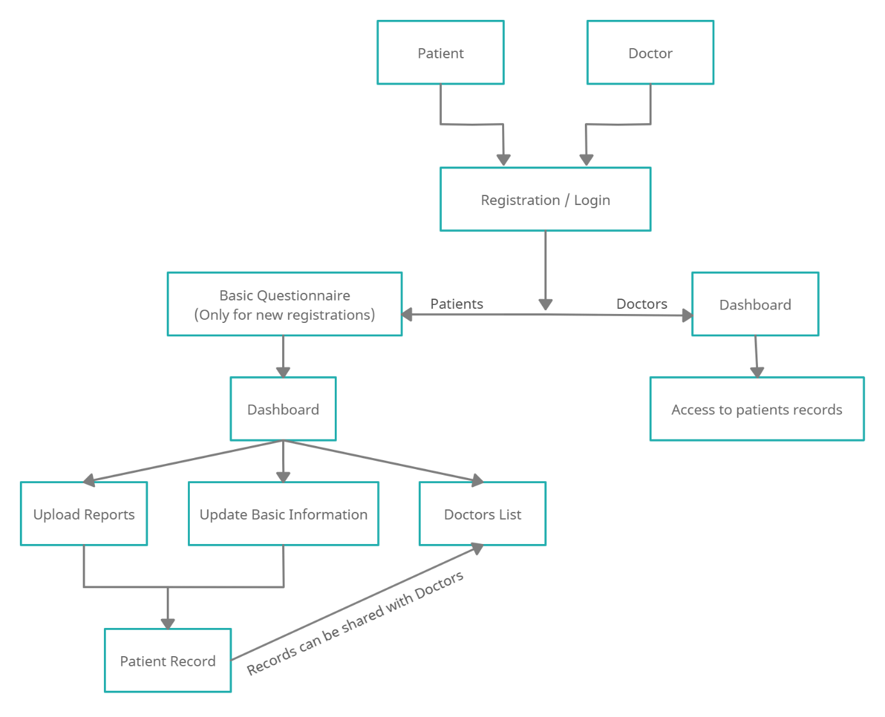

**2.4 Modules**

* Registration / Login
* Patient Dashboard
* Upload Reports
* Share Reports with Doctors
* Basic Information
* Doctor Dashboard
* View Patient Reports

**3. Planning For Next Semester**

* Build a proper working model of all the modules
* Improvise on those modules, under the guidance of project guide
* Combine all the working modules properly to create the system
* Create the system having functionality as mentioned in the report
* Adding any extra features to system, under guidance of project guide